Codebasics SQL Challenge

Requests:

**1. Provide the list of markets in which customer "Atliq Exclusive" operates its business in the APAC region.**

Solution:

SELECT customer_code,Customer,region,market FROM gdb023.dim_customer

where customer="Atliq Exclusive" and region="APAC";

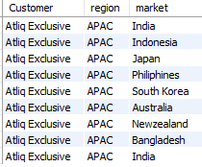

**2. What is the percentage of unique product increase in 2021 vs. 2020? The final output contains these fields, unique_products_2020 unique_products_2021 percentage_chg**

Solution:

select unique_products_2021, unique_products_2020, (unique_products_2021-unique_products_2020)/unique_products_2020*100 percentage_chg from

(select

(select count(distinct product_code) from gdb023.fact_sales_monthly where fiscal_year=2020) unique_products_2020,

(select count(distinct product_code) from gdb023.fact_sales_monthly where fiscal_year=2021) unique_products_2021

from dual) dummy;



**3. Provide a report with all the unique product counts for each segment and sort them In descending order of product counts. The final output contains 2 fields, segment product_count**

Solution:

select count(distinct product_code) 'product count', segment FROM gdb023.dim_product group by segment order by count(product_code) desc;

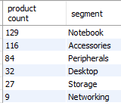

**4. Follow-up: Which segment had the most increase in unique products in 2021 vs 2020? The final output contains these fields, segment, product_count_2020, product_count_2021 difference**

Solution:

select segment, sum(product_count_2021) product_count_2021, sum(product_count_2020) product_count_2020, sum(product_count_2021)-sum(product_count_2020) difference from

(select count(distinct DP.product_code) product_count_2021, segment, null product_count_2020 FROM gdb023.dim_product DP, gdb023.fact_sales_monthly FSM

where DP.product_code=FSM.product_code and fiscal_year=2021 group by segment

union

select null product_count_2021, segment, count(distinct DP.product_code) product_count_2020 FROM gdb023.dim_product DP, gdb023.fact_sales_monthly FSM

where DP.product_code=FSM.product_code and fiscal_year=2020 group by segment) dummy

group by segment;

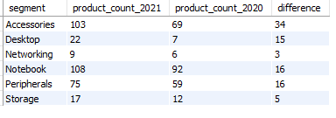

**5. Get the products that have the highest and lowest manufacturing costs. The final output should contain these fields: product_code, product, manufacturing_cost**

select FMC.product_code product_code, Product, manufacturing_cost from gdb023.dim_product DP ,

(SELECT product_code, manufacturing_cost FROM gdb023.fact_manufacturing_cost

where manufacturing_cost = (select max(manufacturing_cost) FROM gdb023.fact_manufacturing_cost)

or manufacturing_cost = (select min(manufacturing_cost) FROM gdb023.fact_manufacturing_cost)) FMC

where DP.product_code=FMC.product_code order by FMC.manufacturing_cost desc;



**6. Generate a report which contains the top 5 customers who received an average high pre_invoice_discount_pct for the fiscal year 2021 and in the Indian market. The final output contains these fields, customer_code, customer, average_discount_percentage**

select FPD.customer_code,customer, round(avg(pre_invoice_discount_pct)*100,2) average_discount_percentage

FROM gdb023.fact_pre_invoice_deductions FPD, gdb023.dim_customer DC

where DC.customer_code= FPD.customer_code and FPD.fiscal_year=2021 and market='India'

group by FPD.customer_code,customer order by average_discount_percentage desc limit 5;

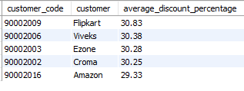

**7. Get the complete report of the Gross sales amount for the customer “Atliq Exclusive” for each month. This analysis helps to get an idea of low and high-performing months and take strategic decisions. The final report contains these columns:,Month, Year, Gross sales Amount**

select Month, Year, round(sum(gross_price * sold_quantity),2) 'Gross sales Amount' from gdb023.fact_gross_price FGP,

(select product_code,customer_code,date_format(FSM.date,'%M') Month,date_format(FSM.date,'%Y') Year, sold_quantity

from gdb023.fact_sales_monthly FSM

where customer_code in (select customer_code from gdb023.dim_customer where customer='Atliq Exclusive' )) Dummy

where FGP.product_code=Dummy.product_code

group by Month, Year

order by Year;

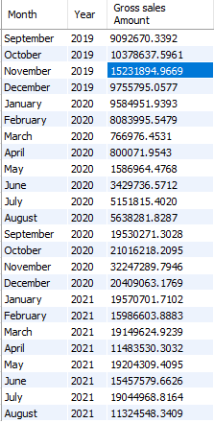

**8. In which quarter of 2020, got the maximum total_sold_quantity? The final output contains these fields sorted by the total_sold_quantity, Quarter, total_sold_quantity**

select case

when date_format(date,'%M') in ('September','October','November') then 'Quater 1'

when date_format(date,'%M') in ('December','January','February') then 'Quater 2'

when date_format(date,'%M') in ('March','April','May') then 'Quater 3'

else 'Quater 4' end 'Quarter', sum(sold_quantity) total_sold_quantity

from gdb023.fact_sales_monthly where date_format(date,'%Y')=2020 group by Quarter;

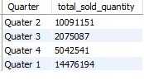

**9. Which channel helped to bring more gross sales in the fiscal year 2021 and the percentage of contribution? The final output contains these fields, channel, gross_sales_mln, percentage**

select channel, gross_sales_mln, round(gross_sales_mln/total_gross_sales_mln*100,2) percentage from

(select channel, sum(sold_quantity*gross_price) gross_sales_mln

from gdb023.dim_customer DC, gdb023.fact_sales_monthly FSM, gdb023.fact_gross_price FGP

where DC.customer_code=FSM.customer_code and FSM.fiscal_year=2021

and FSM.fiscal_year=FGP.fiscal_year and FSM.product_code=FGP.product_code

group by channel)table1,(select sum(sold_quantity*gross_price) total_gross_sales_mln from gdb023.fact_sales_monthly FSM, gdb023.fact_gross_price FGP

where FSM.fiscal_year=2021 and FSM.fiscal_year=FGP.fiscal_year and FSM.product_code=FGP.product_code) table2

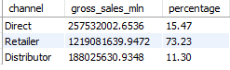

**10. Get the Top 3 products in each division that have a high total_sold_quantity in the fiscal_year 2021? The final output contains these fields, division, product_code, product, total_sold_quantity, rank_order**

select * from (

SELECT division,DP.product_code, DP.product, sum(sold_quantity) total_sold_quantity,

rank() over(partition by division order by sum(sold_quantity)) rank_order

FROM gdb023.dim_product DP, gdb023.fact_sales_monthly FSM

where DP.product_code=FSM.product_code

and FSM.fiscal_year=2021

group by division,product_code, DP.product ) tble where rank_order<4

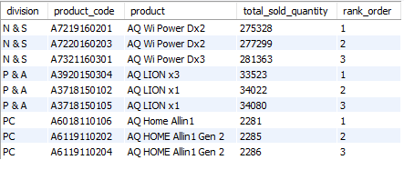

Note:

1. The submissions are evaluated based on the query readability, logic, and also

presentation of the results.

2. We recommend you create a presentation video assuming presenting to the

business stakeholders and create a Linkedin post that contains the link to GitHub

files (SQL codes, Presentation document), video presentation, and also your

experience while working on this challenge.

3. Submit your post link on the resume project challenge page of codebasics.

(https://codebasics.io/event/codebasics-resume-project-challenge)

codebasics.io